Abstract Model

Abstract must be written in English, limited to 3 (three) pages, in PDF format. It will be used to evaluate the submitted work for prize concession.

(an abstract example is given in the next page)

Page Format: page format A4 (210 x 297 mm), portrait, superior and inferior margins 3 cm, left and right margins 2.5 cm, font Times New Roman 12 (except for the title) and single spaced.

Title: on the page top, font 16, bold and centered. Do not capitalize the title.
Add a blank line, single spaced (font 12), before the name of the authors.

Authors: font normal, centered. Underline the author´s name who will present the work. Use numeric superscripts to identify authors’ affiliations (omit the identification if there is only one institution).
Add a blank line, single spaced (font 12), before the addresses.

Address: italic, centered, use the numeric index on the left side.
Present the authors' affiliation addresses. Indicate affiliations with the superscript number used at the author's name.
Do not add a blank line, single spaced (font 12), before the e-mail.
e-mail: italic, centered, inform the e-mail address of the corresponding author.
Add two blank lines, single spaced (font 12) before the abstract.

Abstract: Times New Roman 12, normal, justified, it may contain figures, tables, photographs, etc. Do not add blank lines, single spaced (font 12), before the keywords.
Keywords: indicate up to 5 words that represent your work.
Add 2 blank lines, single spaced (font 12) before the next session.

Introduction
Times New Roman 12, normal, justified. The text may contain figures, tables, photographs, etc.
Add 2 blank lines, single spaced (font 12) before the next session.

Experimental Procedure
Times New Roman 12, normal, justified. The text may contain figures, tables, photographs, etc.
Add 2 blank lines, single spaced (font 12) before the next session.

Results and discussion
Times New Roman 12, normal, justified. The text may contain figures, tables, photographs, etc. There is no limit to the number of figures or tables.
Add 2 blank lines, single spaced (font 12) before the next session.

Conclusions
Times New Roman 12, normal, justified.
Add 2 blank lines, single spaced (font 12) before the next session.

Acknowledgements (optional)
Times New Roman 12, normal, justified.
Add 2 blank lines, single spaced (font 12) before the next session.

References (optional)
Times New Roman 12, normal, justified. Use the format presented in the next page. There is no limit to the number of references.

Do not use page numbers, headline and footnote.

Additional Information:
The abstract will be accessible and its edition will be allowed until the deadline of submission of the extended abstracts.
Extended abstract must be submitted AFTER receipt of “accepted work” by the organizing committee, using the site of the meeting (https://sbpmat.org.br/18encontro/), by the link for “submission”.

Manuscript title model for the XVIII B-MRS event

G. Hamer¹, A. N. Kength¹, C. Silvado², M.A. Saberia¹, R.P. Bequer¹

¹Washington University, Department of Physics, St. Louis, USA
²Universidade de São Paulo, Instituto de Física de São Carlos, SP, Brazil
e-mail: contactauthor@inst.uni.br

Abstract: xxxxxxx
Keywords: xx, xx, xx, xx, xx.

Introduction

Xxxxx

Experimental Procedure (or Computational Procedure)

XXXX

Results and Discussion

Xxxxx

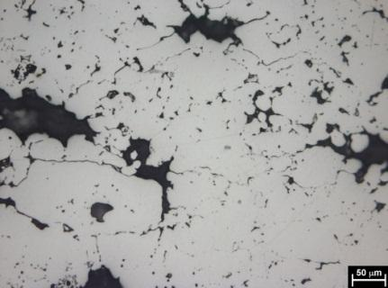 | 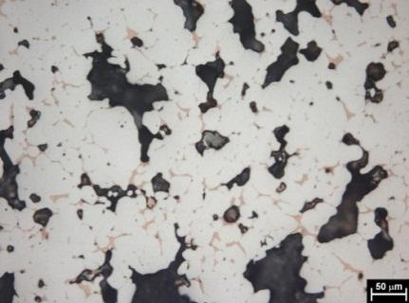  (b)
Figure 1: xxx. (a) xxx; (b) xxx.
(a)

Table 1 – xxx.
 | Condition 1 | Condition 2 | Condition 3
Sample 1 | 111 | 333 | 555
Sample 2 | 222 | 444 | 666

Conclusions

Xxxxxx

Acknowledgments

This work was supported by <sponsorship agencies, ex: CNPq, CAPES or FAPESP>.

References

[1] J. van der Geer, J.A.J. Hanraads, R.A. Lupton, The art of writing a scientific article, J. Sci. Commun. 163 (2010) 51–59.
[2] W. Strunk Jr., E.B. White, The Elements of Style, fourth ed., Longman, New York, 2000.
[3] G.R. Mettam, L.B. Adams, How to prepare an electronic version of your article, in: B.S. Jones, R.Z. Smith (Eds.), Introduction to the Electronic Age, E-Publishing Inc., New York, 2009, pp. 281–304.

