Abstract template

This is an abstract template written in English for the XI SBPMat Meeting Proceedings.
The abstract must be in an A4 page (210 mm x 297 mm, portrait, 3.0 cm top and bottom margins and 2.5 cm left and right margins).
Please underline the name of the presenting author and place the email and contact address on the last line, after references. Also list the keywords.
Please do not number the page and not use header and footer.
Use single spacing, Times New Roman 12 font for all text and 18 font for the title. For additional instructions and how to submit the abstract, access http://sbpmat.org.br/11encontro.
Please prepare the abstract in Word file and paste graphics and photos (if necessary). For references, see example below.
After carefully checking the text, save the file as pdf and submit it. There will be no text edition after its submission.

See abstract example on next page!

Liquid phase sintering of self-lubricating Fe-hBN composites

G. Hammes¹, A. N. Klein¹, C. Binder¹, M.V. Silveira¹, R.P. Becker¹
¹ Universidade Federal de Santa Catarina, Florianópolis, SC, Brazil

When conventional powder metallurgy is used to process materials with embedded lamellar solid lubricants, by adding it as powder during mixing process, spreading of solid lubricant occurs during mechanical homogenization due to its low shear strength, forming films. This restrains the formation of contacts during sintering, which results in low mechanical properties of the material [1]. In order to improve the distribution of the solid lubricant in the matrix, liquid phase sintering can be used to process the material [2]. In the present work, self-lubricating composites presenting embedded solid lubricant (hexagonal boron nitride - hBN) in a ferrous matrix, with and without liquid phase during sintering, were produced. The chosen element to form liquid phase was copper. The samples were produced by mixing powders, pressing at 700 MPa and sintering at 1125 °C, with atmosphere of 95%N₂/5%H₂. The liquid phase sintering, by adding copper, improved the degree of continuity of the matrix by rearranging the solid lubricant particles (Figure 1). With this, besides the hardening effect of the copper on the matrix, the mechanical properties of the composites were improved, with tensile strength increasing up to 230% when compared to the same composite without copper (Table 1).

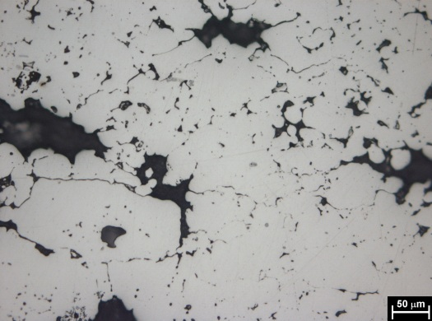 | 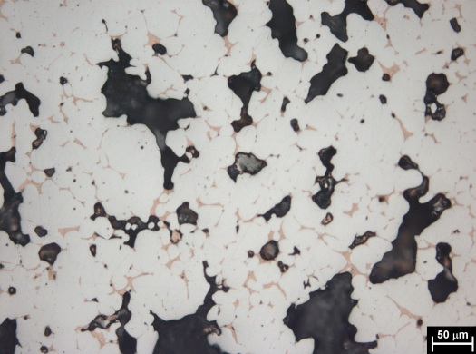  (b)
Figure 1: Optical micrographs of sintered iron samples containing 5 vol% hBN, with no liquid phase during sintering (a) and with liquid phase by adding 15 wt% (b).
(a)

Table 1 – Tensile strength of sintered samples.
 | 0 vol% hBN | 2,5% vol% hBN | 5% vol% hBN
0 wt% Copper | 202 MPa | 124 MPa | 77 MPa
15 wt% Copper | 306 MPa | 293 MPa | 255 MPa

Keywords: Powder metallurgy, Liquid phase sintering, Self-lubricating composite.
[1] A.N. Klein, C. Binder, G. Hammes; J.D.B. de Mello, W. Ristow Jr, R. Binder. Proceedings of EURO PM2009, Vol. 1(2009) 191-196;
[2] R. Binder, A.N. Klein, C. Binder, G. Hammes, M.L. Parucker, W. Ristow Jr. Patent application PI 0803956-9, INPI, Brazil, 2008.
gisele@emc.ufsc.br – Labmat, UFSC, C.P. 476, CEP 88040-900, Florianópolis, SC, Brazil

